Blue brain project
Starting-
1-the Blue brain project is a Swiss brain research initiative that aims to create a digital reconstruction of the mouse brain.
2-the project was founded by the brain and mind institute of ecole polytechnique federal Lausanne(EPFL)in Switzerland.
3-Its mission is to use biologically detailed digital reconstruction and simulation of the mammalian brain to identify the fundamental principles of brain structure and function.
4-The project is headed by the founding director Harry Markram who also launched a human brain project and is Co directed by Felix is scupermann, Adrian Salvatore and Sean hill.

GOAL-
1-The initial goal of the project which was completed in December 2006 it was the creation of a simulated rat neocortical column.
2-It was considered by some researchers to be the smallest unit of the neocortex.
3-It was thought to be responsible for higher functions such as conscious thought in human each column is about 2 mm(0.079) in length , has a diameter of 0.5mm(0.020) and contains about 60,000 neurons.
4-Rat neocortical column are very similar in structure but contains only 10,000 neuron. Between 1995 and 2005,markram mapped the types of neuron and their connection in such a column.

Progress-
1-by 2005,the first cellular model was completed. The first artificial cellular neocortical columns of 10,000cells was built by 2008.
2- by July 2011,a cellular mesocircuit of 100 neocortical columns with a million cells in total was built. A cellular rat Brain had been planned for 2014 with hundred mesocircuit totaling a 100 million cells.
3-a cellular human brain equivalent to 1000 rat Brain with a total of a hundred billion cells has been predicted by 2023.
4-in November 2007,the project reported the ends of the first phase, delivering a data driven process for creating, validating and researching the neocortical column.

5-in 2015, scientists of(EPFL) developed a quantitative model of the previously unknown relationship between the glial cell astrocytes and neurons.

6-The additional layer of neuron glial cell is being added to blue brain project models to improve functionality of the system.
7-In 2017 blue brain project discovered that neural cliques connected to one another in up to 11 dimensions the projects editor and director suggested that the difficulty of understanding the brain is partly because the mathematics usually applied for studying network cannot detect that many dimensions.
8-The blue brain project brain was able to model these network using algebraic topology in 2018 blue brain project released its first digital 3D brain cell Atlas which according to Science Daily is like “going from hand drawn maps to Google Earth ”providing information about major cell types number and position in 737 regions of the brain.

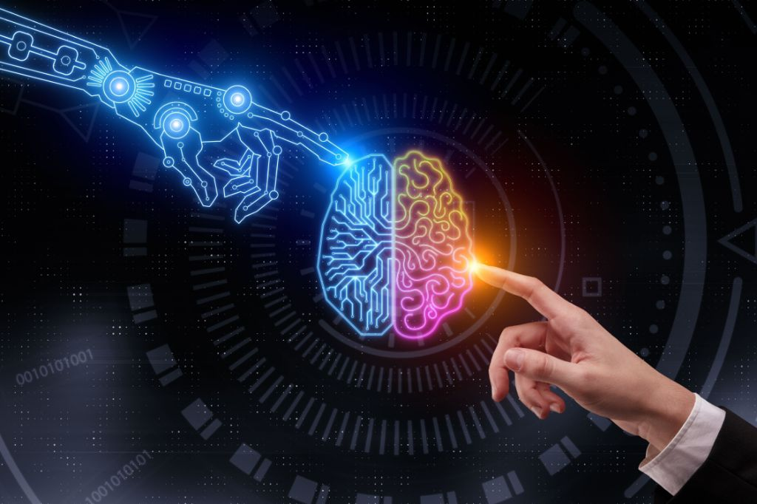
9-In 2019 ,Idan segev one of the computational neuroscientists working on the blue brain project gave a talk titled “brain in the computer what did I learn from stimulating the brain” in his talk he mentioned that the whole cortex for the mouse brain was complete and virtual EEG experiments would being soon. he also mentioned that the model had become too heavy on the supercomputer they were consequently exploring methods.
10-In that methods every neuron could be represented as a neural network.
……………… ✖️………………
Thank you,
Name- Dheeraj fulara
Class-IX(d)
Subject-(IT)
Project work,
Topic-BLUE BRAIN PROJECT

